Green Lane Church of England Primary School

Draft Wellbeing Strategy 2023-25

It is widely recognized that a child’s emotional health and wellbeing influences their cognitive development and learning, as well as their physical and social health and their wellbeing in adulthood. The Department for Education recognizes that in order to help pupils succeed, schools have a role to play in supporting them to be resilient and mentally healthy.

Our Wellbeing Vision
Through teaching the children, training the staff, involving our parents in our shared vision and having a whole school approach to the importance of healthy bodies, healthy minds, acts of kindness and happiness for all we can support our Green Lane community to be happy, healthy individuals. Through our curriculum, we talk to the children about mental health, particularly through collective worship, story time, PE and PSHE and wellbeing sessions. Our children are learning that we all have mental health and that, just like physical health, sometimes we can feel fantastic, but other times we might not feel so good. They understand and accept that we all have times when we don’t feel good about things and that to have someone that we can talk to can make all the difference. We have a Wellbeing Team in place, including staff and children who are driving our vision. Our staff understand that it is crucial that we all share this message – and use it for ourselves too. We worked with Deborah Foster from DCC in the autumn term of 2023 looking at resilience across the school community and this work has helped inform the action plan and our overall strategy.

We aim to:
- Ensure that through the promotion of positive emotional health and wellbeing, children are helped to understand and express their feelings, build their confidence and emotional resilience and therefore their capacity to learn.
- Increase the awareness and understanding and reduce stigma amongst children, staff and parents/carers of issues involving the emotional health and wellbeing of young people and to provide support at an early stage to anyone who is or appears to be suffering from mental health issues.

Our Wellbeing Team
Wellbeing is every member of staff’s responsibility. We are lucky to have such a dedicated and experienced team that cares passionately about every child they have the pleasure of working with. The following members of staff have responsibility for wellbeing- they are the Wellbeing Team and they ensure we have a strategic approach to wellbeing:

Member of Staff | Position
Mr Rob Goffee | Headteacher  Mental Health First Aider
Mrs Nic Linsley | Deputy Headteacher  Wellbeing Lead
Miss Abbie Cone | PHSE and RHSE Lead
Mrs Helen Stannard | SENDCO

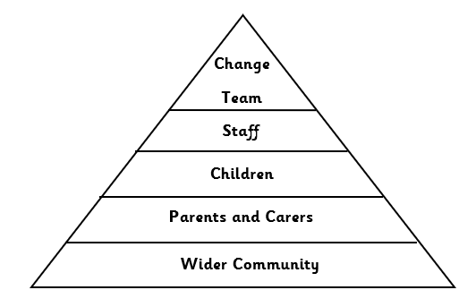
The Wellbeing Team will incorporate the following into their roles:
Delivering staff supervision, training and CPD in relation to wellbeing and mental health
Wellbeing
Team
Drive positive wellbeing across the whole school community
To maintain the action plan for the wellbeing of all stakeholders
To evaluate the impact and outcomes based on the action plan
Engaging parents and promoting family wellbeing
Regularly gather feedback from staff, pupils and parents and take appropriate action!

The Wellbeing Team are supported in school by the Caring Council children and designated Caring Council Ambassadors in each class who meet regularly and discuss the wellbeing of their peers in school.

What is Wellbeing?

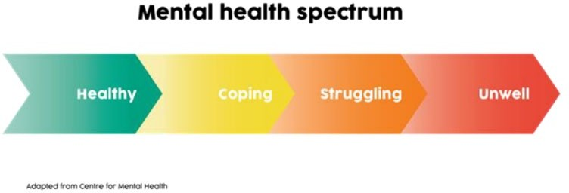
Although definitions vary – and some feel that it is hard to define – there is broad agreement that wellbeing refers to the quality of people’s lives. It is about how well we are, and how our lives are going. There are many ways to define wellbeing, and that is a discussion in itself.

For this guidance, we define ‘wellbeing’ as referenced in the widely accepted World Health Organisation definition of mental health:

“Mental health is defined as a state of wellbeing in which every individual realizes his or her own potential, can cope with the normal stresses of life, can work productively and fruitfully, and is able to make a contribution to her or his community.”

At Green Lane, we believe that to be successful in school, pupils need to feel safe, happy and confident. We believe that when we get wellbeing right, pupils will achieve their academic potential and ability.

How do we promote a positive mental health?

- Promote knowledge and understanding of both internal and external support services.
- Encourage and support the whole school community to be positive in its approach to mental health wellbeing
- Provide guidance and support to all those connected with the organisation to help them develop confidence in their ability to manage mental health and emotional wellbeing.
- Provide appropriate training and information to staff on mental health and emotional wellbeing.
- Have named a Wellbeing Team who are the contact point at Green Lane Primary who are responsible for co-ordination and delivery of the school’s mental health and emotional wellbeing strategy.
- Seek to embed mental health and emotional support across the curriculum.
- To raise the resilience levels of pupils and staff across our school community by setting clear actions in place.

What do we do if we believe a child or member of staff needs support?

Any member of staff who is concerned about the mental health or wellbeing of a child should speak to the Wellbeing Lead in the first instance and complete a Wellbeing Support Referral form. If there is a fear that the student is in danger of immediate harm then child protection procedures should be followed with an immediate referral to the Designated Safeguarding Lead or Designated Deputy Safeguarding Lead. Any other Safeguarding concerns that are non-urgent should be recorded via CPOMS.

If a member of staff needs support they can talk to any member of the Wellbeing Team and they can refer the staff member to the appropriate support.

What do we do to identify any wellbeing issues?
- Whole school wellbeing surveys – for children and staff
- PSHE curriculum in place with wellbeing focus
- 1-1 support identified
- Group support identified

What do we monitor in school?
- PSHE and wellbeing sessions timetabled regularly
- 1-1 sessions planned where necessary
- Targeted group support identified for those children who need emotional support
- Regular celebration and reward assemblies recognise achievements in supporting wellbeing/demonstrating resilience.
- Targeted co-ordination of academic support where needed
- Whole staff training and support
- Student voice established
- Whole school and parent events/engagement

- Wellbeing resources in school suitable for all year groups
- Mental health and wellbeing days focusing on specific areas as identified by staff
- Safeguarding

Strategic Overview
To implement the vision, the head teacher and the academy council committed to appointing Mrs Nic Linsley to the role of designated lead for Mental Health and Wellbeing. The Mental Health and Wellbeing lead will be responsible for promoting the wellbeing and positive mental health of pupils, staff and parents. She is supported in this role by the headteacher.

Wellbeing Action Plan
The aim of our plan is to explain what provision is on offer, how and who will ensure it is offered and when and how this will be monitored. The plan will be reviewed regularly by the Wellbeing Team and Senior Leadership Team. The action points are reviewed each term at specific staff meetings with a wellbeing and mental health focus. The first of these to be April 2024.
Aim:  Who will this affect? | Accountability:  What we will do to achieve this. By who? | Desired Outcomes | Evaluation and ongoing review
Objective 1  The whole school is committed to promoting and protecting emotional wellbeing and mental health.  Pupils, Staff and Parents/Carers | Wellbeing Lead and SLT to establish a Wellbeing Team, you will engage a range of staff, pupils, parents and academy councillors from across the school community.  Wellbeing Team to audit and evaluate where we stand with supporting mental health and wellbeing for staff, pupil and parents.  Wellbeing Team to create an action plan for the process and monitor it at regular stages.  Questionnaires to be sent out to all stakeholders to gain valuable feedback about the current offer for emotional health and wellbeing. | - Be fully committed to embracing change for positive outcomes of support for mental health and wellbeing for all stakeholders at the school. | - An enhanced provision of mental health and wellbeing to our pupils, staff and families will be established.  - All stakeholders are committed to embracing change for positive outcomes of support for mental health and wellbeing.  - Training provided and planned for whole school community – ongoing to ensure provision is embedded.  - CPD planned for all staff and regular updates for parents/ carers.

Objective 2  The school has a clear vision and strategy for promoting and protecting emotional wellbeing and mental health  Pupils, Staff and Parents/Carers | - A vision statement has been created by SLT that embeds our desired outcomes and that feeds directly onto the school’s vision.  - The strategy has been shared with the whole school community via school website.  - Our provisions will be reviewed regularly by Wellbeing Team and SLT and how well we currently support wellbeing and mental health.  - Wellbeing Team and SLT to create a whole school approach for emotional wellbeing and mental health and links directly with the school’s overall vision.  - SLT to ensure the school policies are in line with the school’s vision on mental health and wellbeing. | - The whole school community understand the vision and embrace any learning around this by committing to the strategy.  - The whole school community play a part in creating the vision and are included in the action plan.  - The school’s provision for supporting wellbeing and mental health is greatly enhanced.  - All staff involved in working with children within the school community have a clear understanding of the risk factors for vulnerable pupils.  - Policies reflect the school’s mental health and wellbeing vision. | - All stakeholders will continue to be updated with information regarding mental health and wellbeing.  - All stakeholders have a clearer understanding of what wellbeing means and a richer knowledge of mental health issues.  - School will be able to facilitate learning gaps around mental health and wellbeing.  - An environment will be created where everyone accepts and understands that positive mental health and wellbeing is the responsibility of all.
Objective 3  The school has a positive ethos which regards the emotional wellbeing and mental health as the responsibility of all  Pupils, Staff and Parents/Carers | - Staff to deliver a clear PSHE curriculum with room for children to share their feelings in a safe environment.  - Wellbeing Team and SLT to organize and deliver raising awareness activities for staff, pupil and parents and make a record of these events.  - SLT to create a culture for staff to share concerns/ worries with one another and support implemented. | - Wellbeing is celebrated and part of whole school culture.  - An environment is created where everyone accepts and understands that positive mental health and wellbeing is the responsibility of all.  - School have created an environment that releases the stigma around mental health.  - Links with the whole school community and stakeholders will drive the school’s vision forward. | - All stakeholders will have a clearer understanding of what wellbeing means and a richer knowledge of mental health issues. Information updated regularly.  - School will be able to facilitate learning gaps around mental health and wellbeing.  - Staff and parents will be able to recognise emotional health issues and respond appropriately.

Objective 4  The school actively promotes staff and pupil emotional wellbeing, mental health and resilience  Pupils, Staff and Parents/Carers | - SLT and school business manager to discuss a budget for staff in order to positively promote mental health and wellbeing in our workplace.  - Regular CPD implemented.  - Appraisal policies and procedures changed to specifically support the emotional wellbeing of staff – SLT to implement.  - Feedback and evaluations take place regularly to gage the wellbeing needs of staff.  - Regular staff wellbeing questionnaires will be completed every 2 years and the results from these analysed.  - Look into the prospect of having supervision sessions each term for staff, so that they can share worries, concerns, anxieties and possible solutions.  - Review out of school day messaging, to reduce workloads and teacher/parent anxiety levels. | - Finances through the school budget will be set aside for staff wellbeing and resources.  - Staff provided with a space to explore their emotional wellbeing within the school appraisal systems.  - An ‘open door’ environment will be created where mental health is an openly talked about subject, therefore the stigma around mental health will be less.  - Greater involvement of all staff will improve relationships, morale and access to support for all.  - Playtime buddies for friendship and emotional support.  - A review of the school’s behaviour systems to reduce low level disruption and to make classrooms calmer, more nurturing environments.  - Ensure that there is a good balance between consequences and rewards in school, so that children are praised more when the display values we want to see across the school community.  - Look at after school / extra-curricular provision, in particular activities that may increase confidence and ultimately resilience of pupils. | - Ongoing communication improvements to be made between staff, incorporating wellbeing into all aspects of school life.  - School to continue to network with outside agencies or services who can provide support.

