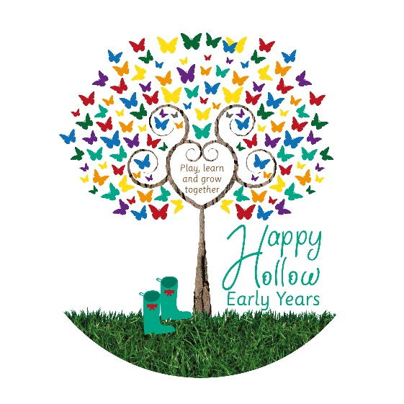
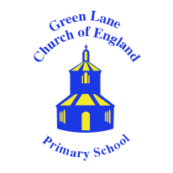
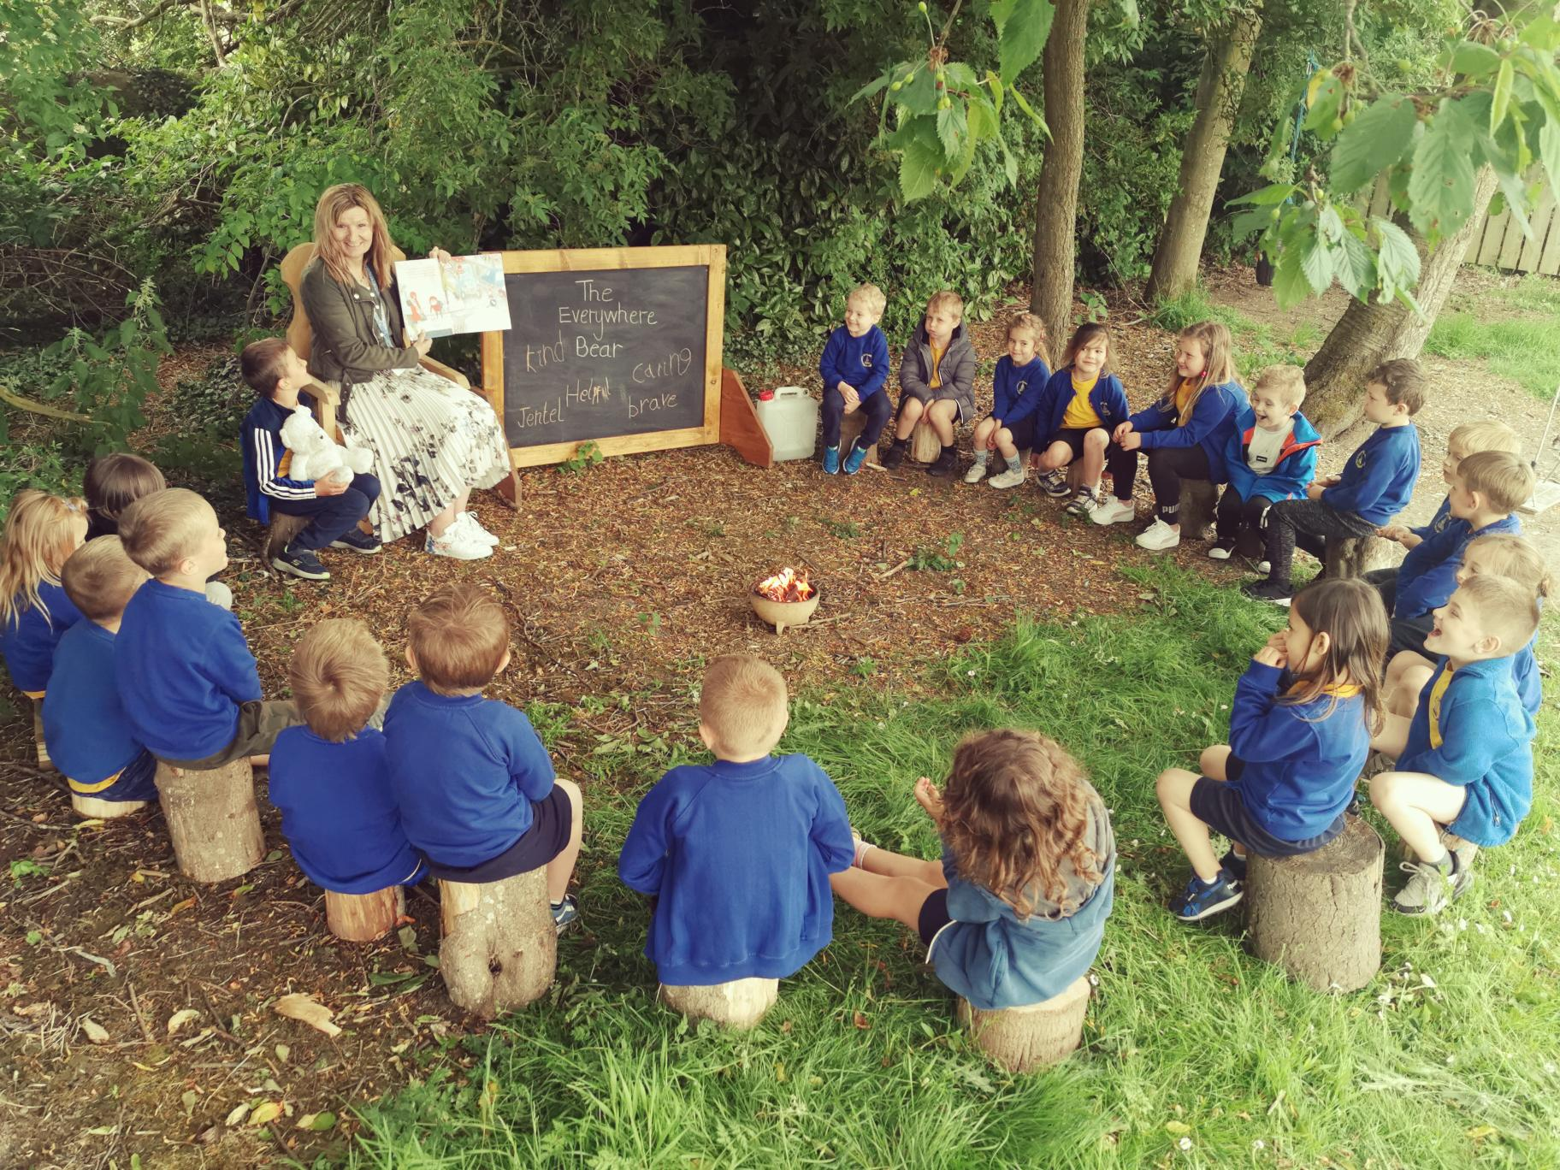
Green Lane Church of England Primary School Prospectus

An Inspiring Place to Be
Green Lane Church of England Primary School has the highest educational aspirations for each and every learner. We combine academic excellence with a caring, nurturing environment that sees our pupils achieve exceptional results. We are more than just a school, we are a family.
In our school everyone succeeds, we ensure that each and every one of our learners leaves our school ready to carry on their educational journey with the highest levels of attainment and with the highest of respect for their friends, their peers, their teachers and their community.
In August 2023 the school was delighted to become part of the Durham and Newcastle Diocesan Learning Trust. As an academy school we can share expertise and ideas with others in the academy in order to further improve the education which we offer to our children.
In February 2023 the school was inspected by Ofsted and achieved a grading of good. The opening sentences of the report sums up what our school is all about: Pupils at Green Lane are confident and articulate. They feel happy and safe in school.
In October 2021 we were delighted when Mr Goffee was announced as the winner of the Headteacher of The Year Award at the Northern Echo’s Education Award, recognising the way our school supported the community during such a difficult period for us all.
In July 2019 the school was judged as being in the top 5% of Church of England schools nationally with a judgement of ‘Excellent’. We offer a fantastic education based around achievement and success in a nurturing, holistic environment. At Green Lane we see the ultimate purpose of education as the promotion of “life in all its fullness” (St John’s Gospel, chapter 10, verse 10).
Here education is about more than just academic achievement; it is about developing young people who can flourish in all areas of their lives developing the intellectual, spiritual, moral and physical attributes, becoming proud and respectful members of our community.
Mr Goffee with two of our fabulous pupils in our woodland themed early years setting:
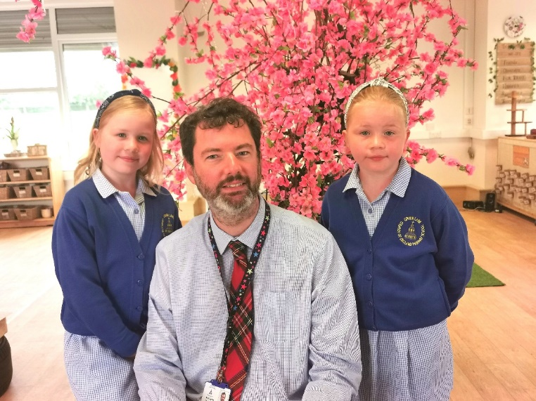

Aims, Ethos and Vision
Green Lane is a Voluntary Controlled Church of England school, and has strong links with St. Mary’s Parish Church in the centre of the town. The children, staff and volunteers are supported in a wide variety of ways to live within the deeply Christian values the school has; this Christian ethos pervades throughout the school, in every room in the school. Our distinctive Christian values are:
Caring – We look after each other, our school and our town
Respectful – We show each other good manners
Forgiving – we show compassion to one another
Honest – We tell the truth
Nurturing – We build each other up to achieve our full potential
Inspiring – We look up to each other with love and kindness
Inclusive – We value everyone
We are a welcoming school with a warm, safe and inclusive atmosphere. The pupils’ behaviour is outstanding and our core Christian values sit at the heart of policy and our day to day practice. The school’s vision is ‘Educating for Life in all its Fullness’ (John 10:10).
At Green Lane we aim to deliver an exciting, inspiring, purposeful and challenging curriculum which is broad and balanced and encompasses not only the intellectual, physical and emotional growth of each child, but also their cultural, moral and spiritual development.
If you’re interested in joining our Team GL family, we would be delighted to invite you to come and have a look around and ask any questions that you might have. You can get in touch with us via email at greenlane@durhamlearning.net, give us a call on 01833 690298 or contact us on Facebook @GLCofE.

The Headteacher is passionate about educating every pupil for ‘Life in all its Fullness’. Leaders have been relentless in the pursuit of excellence for all, shaped by the school’s explicit and distinctively Christian vision.
Church of England Inspection July 2019 – Excellent Rating

Our Church of England inspection:
In July 2019 the school was delighted to be judged as being in the top 5% of Church of England schools nationally with a judgement of ‘Excellent’!
Key findings
Highly innovative work on character development permeates all areas of school life. It focuses on developing the whole child, preparing them for a full and flourishing life.
The school’s deeply Christian vision and its associated values are woven through the work of the school and are a central part of its everyday life. Adults and pupils clearly articulate the vision, its biblical roots and how they impact positively on their lives in school, and beyond. This gives them hope and aspiration to live life to the full.
Leaders at all levels provide a genuinely warm and nurturing environment where pupils, staff and families can be supported to be the best that God created them to be. Excellent relationships across the whole school community, exemplified by the term ‘Team GL’, ensure that everyone feels valued, and encouraged to flourish.

What does Ofsted think of our school?
- Pupils at Green Lane are confident and articulate. They feel happy and safe in school.
- Leaders have formed positive relationships with many families. Parents say they appreciate the support on offer to them from the school.
- Many pupils behave exceptionally well. They are polite and respectful of both each other and adults.
- Pupils know that bullying will not be tolerated and say that it rarely happens. When it does happen, pupils are confident that adults will deal with it quickly.
- Leaders have high expectations of pupils.
- The school’s core Christian values are at the heart of everything that happens in the school.
- A love of reading is fostered as soon as children start in Reception. They have a reading den in their classroom, where they can choose to read a story to a ‘book buddy’. Staff from the local library visit to read stories, and children make their own library cards to use in the school library.
- Leaders have developed an ambitious curriculum that is based on the context of the school. Curriculum plans are coherently sequenced and identify key knowledge that pupils must acquire.
Judged Good by Ofsted February 2023

Academic performance and achievements

Here at Green Lane, we are about so much more than academic performance but pupils at Green Lane do have the opportunity to excel academically. Our end of key stage assessment results are consistently strong throughout all year groups so that by the end of year 6 we have over 90% of pupils achieving age-related expectations or above. Our results put us in the top 5% of primary schools nationally and in the top 10 performing primary schools in County Durham for achieving the standard in reading, writing and maths.

We achieve this by making sure that a strong foundation is laid down when the children first start with us – promoting a love for learning and an inquisitive mind that gives them a thirst for knowledge. Our early years’ children have been judged above the national average for achieving their early learning goals year after year.

Academic success combined with our drive to develop character means that we feel we have the perfect recipe for excellence here at Green Lane…

Developing the Whole Child with a
Character Based Education

Developing character is at the heart of the school’s vision, as is the aspiration that we all have in ensuring that every child succeeds to their highest level. Staff and governors have the highest aspirations for the children in the school and our excellent outcomes at all key stages reflect the success of this vision. We believe that for children to live life to its fullest they need strong resilient characters rooted in the Christian values we instill and they need the academic success to ensure that all of life’s choices are open to them as they go on to become the community leaders of tomorrow.

We have seen the impact of our values on many levels and on many different occasions, they help the children develop resilience and they help them to resolve problems through their links to our restorative approach. The school works directly with the local parish who see Green Lane as a vital part of the church’s wider community. This is never more apparent than during the termly prayer space events when the school becomes populated by the community from St Mary’s helping the children reflect on a range of subjects all aimed at further deepening and developing their understanding of the wider world. These events are part of what makes this school so unique and special, giving children the space to think outside of the school curriculum.

We develop character so that our pupils become confident, resilient, caring, loving people in our community; we have the highest of aspirations for all learners so that they achieve their full potential in a warm, nurturing environment.

Caring Council
At Green Lane we don’t have a traditional School Council, at our school the pupils decided to set up a Caring Council run by Wellness Ambassadors from across our Key Stage 2 classes. This was the brainchild of one of our pupils – Jake Allison – who thought as we are a school that has caring values at its heart we should have a council that promotes them!
Jake organised an application form for everyone who wanted to become an ambassador and he met with our headteacher and deputy head to read through each one and ultimately choose those who displayed the most caring attitudes and had the most empathy to join the Caring Council.
They meet each week with senior leaders to discuss ways in which we can support the wellbeing of our pupils. They helped put reflection zones in each class – a place where pupils can go to if they need a quiet moment.
We listen to our pupils at Green Lane because their ideas are very often the best ideas and help to make our school the caring community it is today…
Sporting Achievement for All
Here at Green Lane we are very proud of our pupil’s reputation for sporting success! We aim to encourage in all pupils the principles of healthy competition and a sense of fair play; we develop individual and team skills to enhance self-esteem and co-operation with others and an ability to abide by a set of rules.

Athletics, gymnastics, football, tennis, swimming, cricket, netball and rounders are all included in the normal curriculum. We have close links with Staindrop School and take part in a variety of sporting festivals on their school site, with a specialist coach attending our school every week to enrich our provision. The school also makes use of the extensive facilities at Teesdale Leisure Centre to broaden the range of activities offered to our pupils.

Sporting links
The School maintains excellent relationships with local sports organisations, most especially with Teesdale Athletic Clubs, Teesdale Leisure Centre, Barnard Castle Football Club, Barnard Castle Rugby Club, Barnard Castle Table Tennis Club and Barnard Castle Cricket Club, many of whom have run after school clubs for our pupils.

Competitions and Events
- Our school teams compete in local and regional competitions with a great deal of success, such as winning the Teesdale Primary School Football League in 2019!
- Our school takes part in the annual ‘Big Meet’ with other local schools and visiting artists, exploring themes such as “Wellbeing”.
- Staindrop Secondary School organise and host sporting festivals for all ages of children throughout the year.
- Each year the children are encouraged to take part in our school’s talent show: Green Lane’s Got Talent!

Extra-curricular activities
The school owes much to those members of the community and teaching staff who, by giving freely of their own time and expertise, provide regular out-of-school Activity Clubs. These are highly successful and very popular! We offer a range of activities including: Football, Glee Club, Multi-skills, Cheerleading, Cricket, Gymnastics, Netball, ICT, Dance, Eco Club, Forest Schools, Rugby, Gardening, Fencing, Cookery, Chess, Card making, Carnival, Community Choir, Table Tennis and Art!

Visits and outings
We believe very much in the importance of providing a rich and varied range of experiences for our children. Educational outings and visits for all age groups are made to places of special interest, and visitors with expertise are regularly invited to the school. Outings have included Bowlees Visitors’ Centre, Washington Wetlands Centre, The Life Centre in Newcastle, the Coast, Durham Cathedral, farm and town visits. Those visiting the school include theatre groups, interfaith visitors, artists and authors.

Annually, we offer a Year 6 residential field study visit for three days of outstanding fun!

It goes without saying that the impact of educational outings and visits on developing and enhancing the curriculum is very significant.

Parents will be notified of any special events (e.g. Church Services, Gymnastics Displays, School Concerts, and Fetes etc.) and are always very warmly welcomed. Expect an invitation to our Friday morning celebration event when your child receives an award!

What our staff and parents think about Green Lane…
It is fantastic being part of the Team GL family, watching and being part of the children’s journey through Green Lane as they develop academically and as a whole person.

I can honestly say that it is a privilege coming to school every day – this is such a warm, joyful place to work!

It's a privilege to work in the caring, nurturing and inspiring learning haven that is Team GL.

This is a school where no one is left behind!

The staff and students of Green Lane Primary are so caring and thoughtful. As they grow through the school it seems to become natural to the students to help those younger than themselves without looking for praise or acknowledgement. That being said, this willingness to support their peers is driven by the kindness and high expectations of the staff, who every day encourage the children to be the best versions of themselves and are quick to celebrate achievements and to recognise compassion in all its forms.

GL Primary School have been absolutely amazing all throughout every Lockdown we’ve all had to cope with, they’ve checked in on every child ensuring they are all safe & well. All the staff have gone above and beyond to ensure constant communication with our children and kept their spirits up throughout this crazy, scary and emotional time for everyone including themselves. They organised our celebration assemblies every week live from school, showing and celebrating all the children’s work and activities during lockdown. Their support to parents has been fantastic. The home-schooling organisation via Teams with our superb teachers and support staff who were always there with encouragement worked so well with our fabulous children who adapted perfectly.

Team GL is a happy workplace, staff and volunteers mould together to inspire our children.

Mr Goffee has motivated everyone at Green Lane (Barnard Castle), the children, parents and school staff, to keep going. His enthusiasm, energy and humour has helped the children and parents feel we were still held within the Team GL family, we weren’t on our own, and helped us feel it was going to be ok. My 8-year-old son will tell you ‘he’s the best, he’s brilliant, funny, caring and kind.’
Constantly evolving
The school opened in 1959 as Baliol Secondary School, in 1977 secondary provision in Barnard Castle was amalgamated and relocated to its current site at Teesdale School. Barnard Castle Junior and Infant Schools then moved into the vacant Green Lane building. In 1980 the two schools were combined to form Barnard Castle Church of England Primary School, now known as Green Lane Church of England Primary School. The school was refurbished a few years ago and we now have full disabled access.

In 2018 the local authority invested significant funds into rejuvenating the front of the school and that began a process of redecoration inside which we celebrated by inviting the whole community in for our Diamond Jubilee event in 2019!

In 2020 we used parental donations and grants to build a brand-new setting for our Early Years children. It is based around a forest school ethos and we call it ‘The Happy Hollow’! We have the staff and the environment to ensure that our children have the best possible start to their educational journeys – learning through curiosity and investigation in a stimulating and interactive setting tailor-made for our young learner.

Mental health and wellbeing
We take the mental health and wellbeing of the school community very seriously at Green Lane. We recognise that mental health is every bit as important as physical health and staff are always on hand to support and to nurture, we believe that a happy school is a successful school. Mrs Linsley, our very experienced Deputy Headteacher takes on the role of wellbeing support, for pupils, staff and parents / carers. We are here to help…

Supporting Disadvantaged Pupils
Green Lane as a Church of England Primary School is committed to equality for all at its very core, here every pupil is given the opportunity to succeed – every pupil is given the tools to be successful – our aim is that every pupil leaves us with at least the national standard in reading, writing, maths and beyond. We see educational achievement as the root out of poverty, we believe that given the chance to succeed every child can and will succeed. We are exceptionally strong at helping those from more deprived homes, those on free school meals, those with a special educational need, those with a barrier to their learning, achieve the highest standards by the time they leave our school. Our aim is that disadvantaged children leave our school with educational standards greater than the national average for children without disadvantage.
Our values are rooted in inclusivity – we inspire our young people to achieve beyond what others might think possible. We do this by helping our children believe that anything is possible.
Quality first teaching is our bedrock – children taught together by teaching staff who have the highest aspirational standards for them.

Links to the community

We have very close links with our parents, carers and community. Our children, parents and carers value our support as we offer pastoral care through a senior leader; who is given quality time to work with pupils, parents and carers alike.

We have many links with the community, for example the younger members of our school regularly visit a local care home, they have drawn pictures for them, entertained and supported them. They have even enjoyed a shared craft morning! This is beneficial for both residents and pupils and they have developed a special bond. Our older children were invited to join with church parishioners to take part in a musical extravaganza at St Mary’s, this brought the school and the community together as did our most recent celebration for the school’s diamond jubilee where over 300 former pupils and staff were welcomed to the school.

We have developed an excellent partnership with the Friends of Green Lane over the years, who have supported our school through countless fundraising events.

Green Lane Nursery and Child Care Centre
The school shares the premises with Green Lane Nursery and Childcare Centre, which is a privately-run nursery and also provides before and after school care for older children. It is a thriving, high quality and well-regarded facility, run as a non-profit making organisation, with charitable status, providing top quality care.
For further information please contact:
Melanie Mitchell - The Nursery Manager
Telephone: 01833 638581
Email: greenlanenursery00@btconnect.com

Church and Community Links

The school has strong links with St. Mary’s Parish Church and celebrates Christian festivals in the church itself. The vicar, Rev. Harding, is Chair of Governors of the school and contributes in a variety of ways to the enhancement of the curriculum. He also regularly leads our collective worship. There are Foundation governors representing the church on the governing body and each has a specific function and responsibility. The skills and knowledge of all governors are put to good use on sub-committees and through links with individual teachers to encourage all with an interest in the school to contribute to its continued success and development.

High Force Education Hub and Durham SCITT

Our High Force Education Hub offers full-time primary level training over one academic year, leading to Qualified Teacher Status and the award of a Professional or Postgraduate Certificate in Education, we deliver this course in partnership with our accredited provider, Durham SCITT.

The programme has its centre at Green Lane and is taught using a partnership of primary schools Durham and North Yorkshire. There is a wide variety of schools within the partnership: very large to very small, urban and rural, denominational and community schools, separate junior and infant, as well as 3 – 11 primary schools from diverse socio-economic backgrounds, all of which give our students a range of teaching experiences.

High Force aims to produce confident, skilled, enthusiastic and inspirational practitioners.

Further information is available from the High Force office 01833 630487 or http://www.highforceeducation.co.uk/

Admissions
Parents and children are always invited in to meet our team and visit the school before they start. It is also an ideal opportunity for meaningful discussion between parents and teachers to ensure the transition from home-life to school to be as smooth and happy as possible for the children. Our staff visit the children in their pre-school setting and the children are invited to visit the school during the summer term before official admission in September. Children transferring from other schools are also welcome to visit before their admission to help with the transition. Give us a ring to arrange a visit or come along to one of our open events held each autumn.

All admissions, including in-year transfers, are dealt with by the Children and Young People’s Service at County Hall. The best way to apply is online www.durham.gov.uk/schooladmissions.

Transition to secondary school
Children will be transferred to Secondary Education when they are eleven years old (on or before 31st August). Parents are able to select the school to which they wish their child to transfer and complete online forms on which to state their preference. The majority of our children transfer to Teesdale School in Barnard Castle and close links exist between the two schools to ease the transition to secondary education. Some children do also go on to Staindrop Academy or Barnard Castle School.

Come and Meet Us…
We would be delighted to show you and your family round the school and answer any questions that you might have. You can get in touch with us via email at greenlane@durhamlearning.net, give us a call on 01833 690298 or contact us on Facebook @GLCofE.
Green Lane CE Primary School
Barnard Castle
County Durham
DL12 8LG
DFE No: 840 3121
T: 01833 690298
F:01833 690316
E: greenlane@durhamlearning.net

